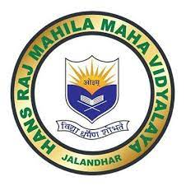
7.2
Best Practices
Best Practice 1-Empowering Women through Skill Enhancement
https://www.hrmmv.org/documents/AQAR-2022-23/Criterion%207/7.2.1Best%20practice%201%2022-23.doc
Best Practice 2-Moving Towards Effective Paperless Office
https://www.hrmmv.org/documents/AQAR-2022-23/Criterion%207/7.2.1Best%20practice%202%202022-23%20(1).doc.pdf

